Ex.no:3 | Data Cleaning

Aim:
To perform data cleaning on the Automobile Market Analytics Dataset by detecting, handling, and removing missing values using various techniques in Pandas.
Algorithm:
Check Missing Values:
Step 1: Start.
Step 2: Import the pandas library.
Step 3: Load the dataset into a DataFrame (df).
Step 4: Display dataset information using df.info().
Step 5: Check missing values using df.isnull().
Step 6: Count missing values using df.isnull().sum().
Step 7: Check missing values using df.isna().
Step 8: Check non-missing values using df.notnull().
Step 9: Display the results.

Drop Missing Values
Step 1: Start.
Step 2: Import the pandas library.
Step 3: Load the dataset into a DataFrame (df).
Step 4: Drop missing rows using dropna().
Step 5: Drop rows (axis=0) or columns (axis=1).
Step 6: Use how='any' to remove rows/columns containing any missing value.
Step 7: Use how='all' to remove rows/columns only if all values are missing.
Step 8: Use thresh=N to keep rows/columns with at least N non-missing values.
Step 9: Use subset=['column_name'] to drop rows based on specific columns.
Step 10: Use inplace=True to modify the original DataFrame.
Step 11: Display the cleaned DataFrame.

Program:
Check Missing Values:
iimport pandas as pd
df = pd.read_csv(r"C:\Users\AI_LAB\Downloads\archive (1)\automobile_dataset.csv")
print("===== INFO =====")
df.info()

print("\n===== TOTAL NULL VALUES =====")
print(df.isnull().sum())

print("\n===== TOTAL NA VALUES =====")
print(df.isna().sum())

print("\n===== NULL VALUES =====")
print(df.isnull())

print("\n===== NA VALUES =====")
print(df.isna())

print("\n===== NOT NULL VALUES =====")
print(df.notnull())

print("\n===== NON-NULL COUNT =====")
print(df.notnull().sum())

print("\n===== TOTAL MISSING VALUES =====")
print(df.isnull().sum().sum())

print("\n===== ANY MISSING VALUES? =====")
print(df.isnull().values.any())

After cleaning:
# Constant Fill
df_constant = df.fillna(0)
print("===== CONSTANT VALUE =====")
print(df_constant)

# Mean Fill (example on numerical column)
df_mean = df.copy()
df_mean["Mileage"] = df_mean["Mileage"].fillna(df_mean["Mileage"].mean())
print("\n===== MEAN =====")
print(df_mean)

# Median Fill
df_median = df.copy()
df_median["Mileage"] = df_median["Mileage"].fillna(df_median["Mileage"].median())
print("\n===== MEDIAN =====")
print(df_median)

# Mode Fill (example on categorical column)
df_mode = df.copy()
df_mode["Fuel_Type"] = df_mode["Fuel_Type"].fillna(df_mode["Fuel_Type"].mode()[0])
print("\n===== MODE =====")
print(df_mode)

# Forward Fill
df_ffill = df.ffill()
print("\n===== FORWARD FILL =====")
print(df_ffill)

# Backward Fill
df_bfill = df.bfill()
print("\n===== BACKWARD FILL =====")
print(df_bfill)Drop Missing:
import pandas as pd
df_drop_rows = df.dropna()
print("===== DROP ROWS =====")
print(df_drop_rows)
df_drop_cols = df.dropna(axis=1)
print("\n===== DROP COLUMNS =====")
print(df_drop_cols)
df_any = df.dropna(how='any')
print("\n===== DROP HOW='ANY' =====")
print(df_any)
df_all = df.dropna(how='all')
print("\n===== DROP HOW='ALL' =====")
print(df_all)
df_thresh = df.dropna(thresh=5)
print("\n===== THRESH=5 =====")
print(df_thresh)
df_subset = df.dropna(subset=['Age', 'Disease'])
print("\n===== SUBSET (Age, Disease) =====")
print(df_subset)df.dropna(inplace=True)

print("\n===== AFTER inplace=True =====")
print(df)
Drop missing values:
df_drop_rows = df.dropna()
print("===== DROP ROWS =====")
print(df_drop_rows)

df_drop_cols = df.dropna(axis=1)
print("\n===== DROP COLUMNS =====")
print(df_drop_cols)

df_any = df.dropna(how='any')
print("\n===== DROP HOW='ANY' =====")
print(df_any)

df_all = df.dropna(how='all')
print("\n===== DROP HOW='ALL' =====")
print(df_all)

df_thresh = df.dropna(thresh=15)
print("\n===== THRESH=15 =====")
print(df_thresh)

df_subset = df.dropna(subset=['Make', 'Year', 'Mileage', 'Selling_Price'])
print("\n===== SUBSET (Important Columns) =====")
print(df_subset)

df.dropna(inplace=True)
print("\n===== AFTER inplace=True =====")
print(df)

Output:
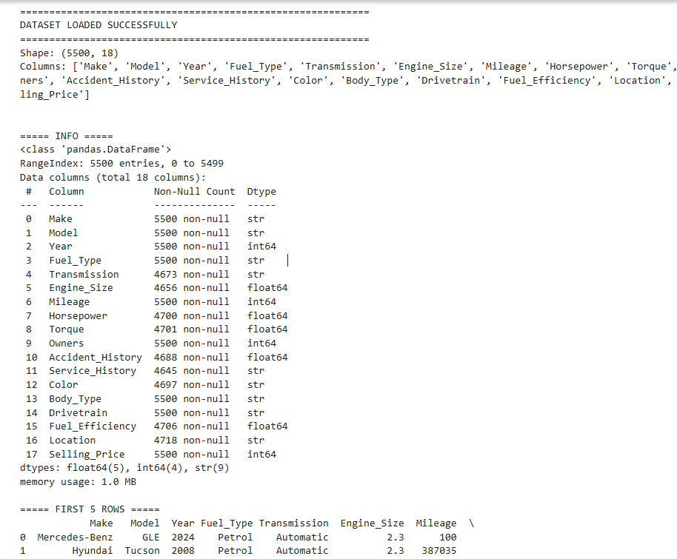
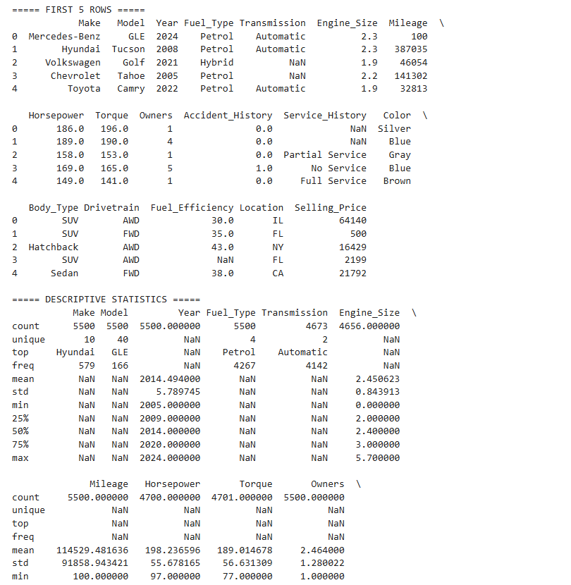
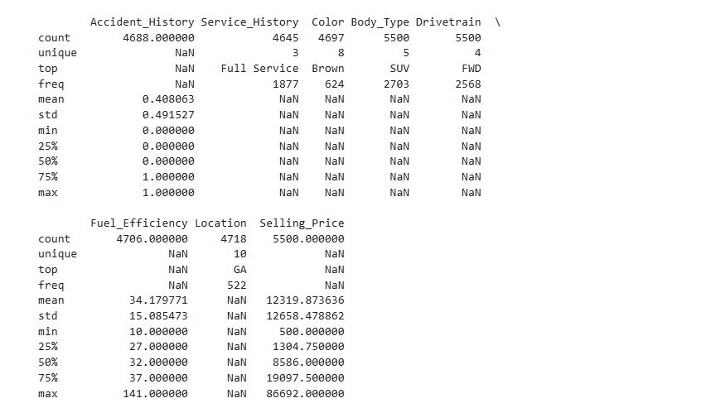
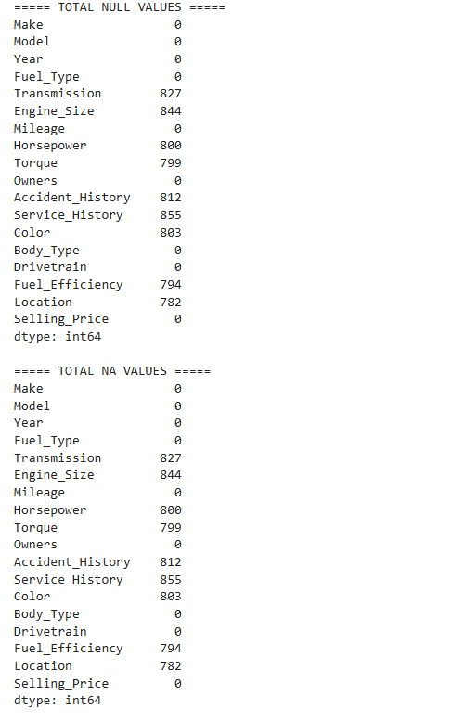
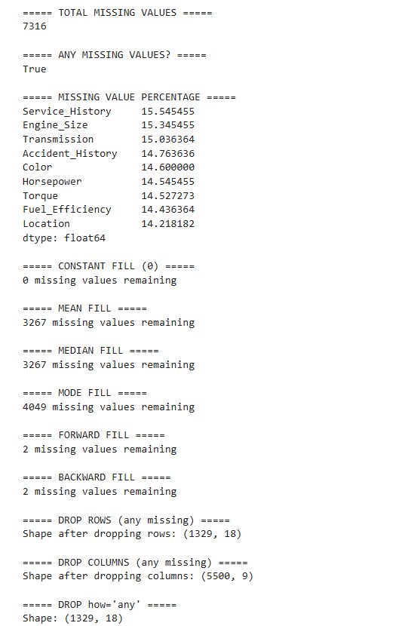
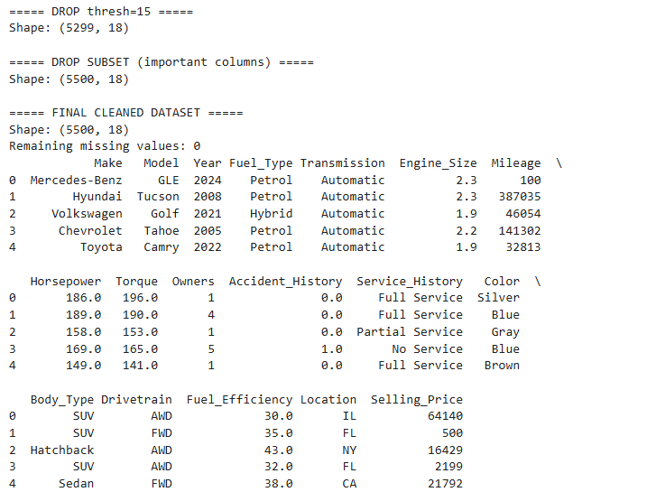

Result:

